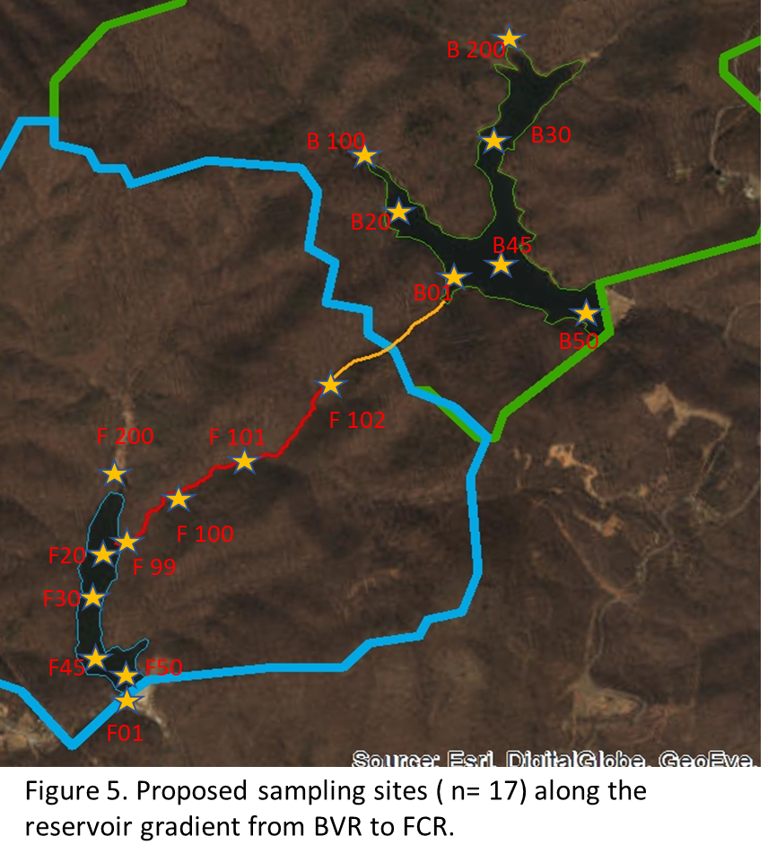**RESERVOIR CONTINUUM SAMPLING FIELD and TRACKING SHEET**

**Site: ______________________________________________**

**Date: _____________________________________________**

**Weather: ________________________________________**

**Crew: ____________________________________________**

ALL SAMPLES AND MEASUREMENTS COLLECTED @ SURFACE (~0.1m)

|  |  |
| --- | --- |
| **Samples to be collected** | **List Sites Collected** |
| Chlorophyll-a |  |
| Total nutrients |  |
| Soluble nutrients |  |
| DOM Quality (EEMs) |  |
| BDOC? |  |
|  |  |
|  |  |

|  |  |  |  |  |  |
| --- | --- | --- | --- | --- | --- |
| **Physical Measurements** Temp Sensor ID: __________________________ | | | | | |
| DO Sensor ID: ____________________________ Cond Sensor ID: __________________________ | | | | | |
| **Site** | **Time** | **Temp (C)** | **DO (mgL)** | **DO %Sat** | **Sp Cond** |
|  |  |  |  |  |  |
|  |  |  |  |  |  |
|  |  |  |  |  |  |
|  |  |  |  |  |  |
|  |  |  |  |  |  |
|  |  |  |  |  |  |
|  |  |  |  |  |  |
|  |  |  |  |  |  |
|  |  |  |  |  |  |
|  |  |  |  |  |  |
|  |  |  |  |  |  |
|  |  |  |  |  |  |

NOTES:

**RESERVOIR CONTINUUM DISCHARGE DATA SHEET**

|  |  |  |  |
| --- | --- | --- | --- |
| **Discharge** | | | |
| Flowmeter Sensor used: | | | |
| Site | Width Interval (m) | Depth (cm) | Velocity (**ft/s** or **m/s**) |
|  |  |  |  |
|  |  |  |  |
|  |  |  |  |
|  |  |  |  |
|  |  |  |  |
|  |  |  |  |
|  |  |  |  |
|  |  |  |  |
|  |  |  |  |
|  |  |  |  |
|  |  |  |  |
|  |  |  |  |
|  |  |  |  |
|  |  |  |  |
|  |  |  |  |
|  |  |  |  |
|  |  |  |  |
|  |  |  |  |
|  |  |  |  |
|  |  |  |  |
|  |  |  |  |
|  |  |  |  |
|  |  |  |  |
|  |  |  |  |
|  |  |  |  |
|  |  |  |  |
|  |  |  |  |
|  |  |  |  |
|  |  |  |  |
|  |  |  |  |
|  |  |  |  |
|  |  |  |  |
|  |  |  |  |
|  |  |  |  |
|  |  |  |  |
|  |  |  |  |
|  |  |  |  |
|  |  |  |  |
|  |  |  |  |
|  |  |  |  |
|  |  |  |  |